Task1 : check whether /user/acadgild directory exists or not in the HDFS

If it doesn’t exist , then create this.

Create a directory /user/acadgild/Hadoop

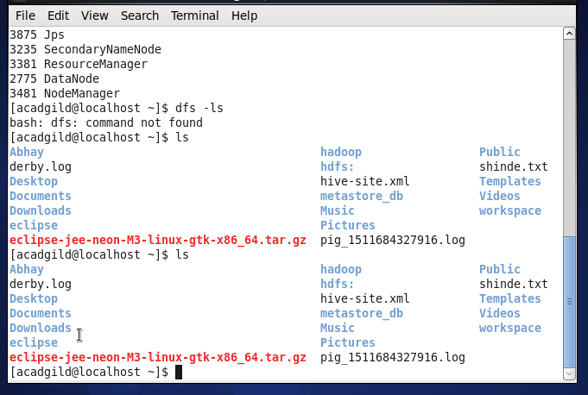

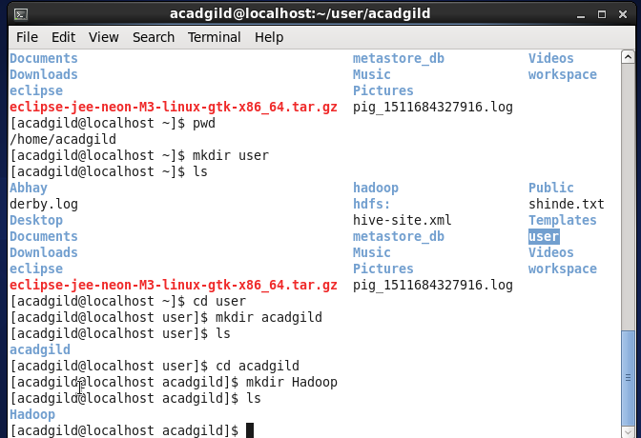

Task 2

Create a file in HDFS under directory user/acadgild/Hadoop , with name word-count.txt

Whatever we type on screen should get appended to the file.

Try to type (on screen) few lines from any online article or textbook

